**B.M.S College of Engineering**

**P.O. Box No.: 1908 Bull Temple Road,**

**Bangalore-560 019**

**DEPARTMENT OF INFORMATION SCIENCE & ENGINEERING**

**Course –Object oriented programming using C++**

**Course Code –18IS3PCOOP**

**AY 2020-21**

**Title:**

**[SWITCHBOX ROUTING]**

**Submitted to – Dr V Shubha Rao**

Submitted by -

**POTHURI YATISH SRIRAM(1BM19IS111)**

**PRANAVA ADIGA (1BM19IS112)**

# TABLE OF CONTENTS

|  |  |  |
| --- | --- | --- |
| **SNO** | **CONTENT** | **PAGE NO** |
| 1 | ABSTRACT | 3 |
| 2 | CONCEPTS OF OOPS | 4 |
| 3 | INTRODUCTION | 5 |
| 4 | PROGRAM DIAGRAM | 6 |
| 5 | SNAPSHOTS | 7 |
| 6 | SOFTWARES | 8 |
| 7 | MODIFICATION | 9 |

**ABSTRACT**

Our aim was to make a tool or a simple application that allows a local electrical company to find whether a switchbox is routable or not keeping in mind do's and don'ts while making connections in a switch box . In improve the performance of the application we have incorporated concepts of OOPS such as file handling , modularity , data protection , and many more which are listed further below . The tool allows the user to find out whether his/her switch box is properly routed and even records the processing data for deeper analysis when any kind of problem arises .The report is structured in a manner where firstly the documentation related to the oops concepts used is presented and followed by introduction , as in how to operate the tool and its limitations finally a few snapshots are attached of a working model.

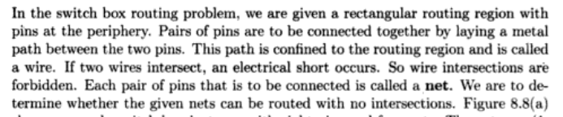**PROBLEM DESCRIPTION**

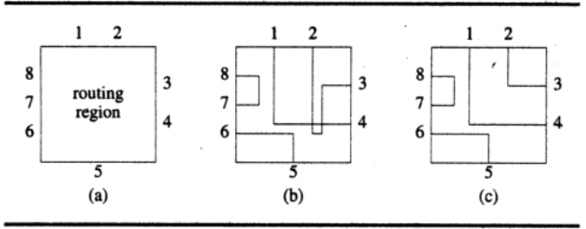

**OOPS CONCEPTS USED**

## *CLASSES AND OBJECTS*

A class in C++ is the building block that leads to Object-Oriented programming. It is a user-defined data type, which holds its own data members and member functions, which can be accessed and used by creating an instance of that class. A C++ class is like a blueprint for an object. An object is an instance of a class. When a class is defined, no memory is allocated but when it is instantiated (i.e. an object is created) memory is allocated.

In our project we have used 3 classes namely stack which contains the memory required for the nodes in the stack to store data and it also has its native member functions that implement various stack operations . Next comes the class called switchbox which is inherited from the stack in public mode ,what is inheritance is explained shortly , this class contains variable like no of pins and the net connections array that are used to store the input data, also has member functions that help in determining whether the given switch box is routable or not. Finally we have a class called file handler which stores and retrieves the user data from the file.

***INHERITANCE***

In C++, **inheritance** is a process in which one object acquires all the properties and behaviours of its parent object automatically. In C++, the class which inherits the members of another class is called derived class and the class whose members are **inherited** is called base class. Like for example the object of sbox class in our program can access the member functions only of the stack class as it inherited in public mode.

***Operator overloading AND FRIEND FUNCTION***

In C++, we can make operators to work for user defined classes. This means C++ has the ability to provide the operators with a special meaning for a data type, this ability is known as operator overloading. In our program we have overloaded >> operator to take in the newly defined class object just like any cin>>variable .This overloading function is defined as a friend function for better flexibility to it and so it needn't be bound to one class member function.

***FILES***

Files are used to store data in a storage device permanently. File handling provides a mechanism to store the output of a program in a file and to perform various operations on it. We use files to store and manipulate the record data in the TXT or CSV files.

***STL***

The Standard Template Library (STL) is a set of C++ template classes to provide common programming data structures and functions such as lists, stacks, arrays, etc. It is a library of container classes, algorithms, and iterators . It is a generalized library and so, its components are parameterized .Also Sequence Containers, implement data structures which can be accessed in a sequential manner .One such example is a string vector which we have used to use to store and retrieve data from files.

***MODULARITY***

Modular programming is a software design technique that emphasizes separating the functionality of a program into independent, interchangeable modules, such that each contains everything necessary to execute only one aspect of the desired functionality. To acheive this property we have divided whole program into main executable file, class declarations , class definition .This allow to reuse the code and make necessary updates without disturbing the core.

***ENCAPSULATION AND ABSTRACTION***

In normal terms Encapsulation is defined as wrapping up of data and information under a single unit. In Object Oriented Programming, Encapsulation is defined as binding together the data and the functions that manipulates them.

Data Abstraction is a process of providing only the essential details to the outside world and hiding the internal details, i.e., representing only the essential details in the program.As we can see that during public inheritance the sbox class only inherited the functions the help to access the stack memory but not the memory itself . Also by keeping the data variables in the private and protected section they can't be accessed outside the class even with an object.

**INTRODUCTION**

To understand the working of the tool first of we need to know about what is a switchbox ,it is basically a junction box for different wire connection in a building .Since the switch should be mostly used at the time of repairs to understand the connections made earlier is a difficult task . So in a manner our application supports the user with the history of records and connections made previously . Also the processing data at the time of connection for analysis.

Firstly the user has to enter his/her name in the command line input and later the user will be prompted with choices as to if they want to check their switch box routable , or to check the records for previously usage data , or to take a look at the processing data for deeper analysis .If the user opts to check his/her switch box then they have to enter the no of pins in their switchbox and their respective connections .

While entering the connections he/she has to enter the data is the format as posted below,

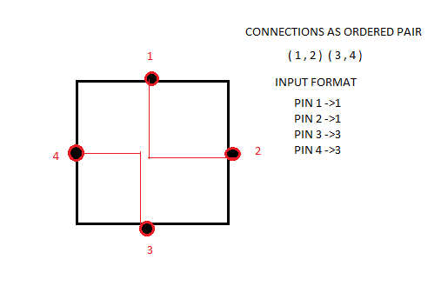

Also the no of pins should always be an even number is it is an odd number the application doesn't accept the input .After processing the data the status of the box is displayed and to see previous records of the same user he/she can view their records by providing their name .

**WORKING OF THE APPLICATION WITH SNAPSHOTS**

**SOFTWARES USED**

* VISUALSTUDIO CODE
* WINDOWS / LINUX

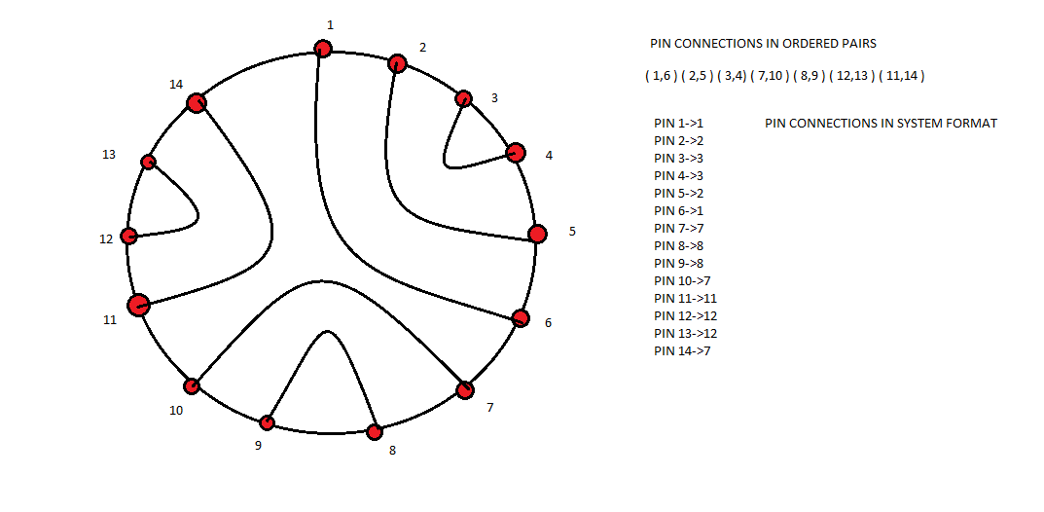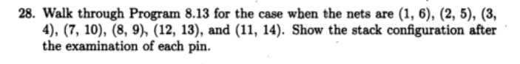**MODIFICATION QUESTION**